**UNIVERSITI MALAYSIA TERENGGANU**

**SEMESTER 1 2023/2024**

**CYBER SECURITY CSF3233**

**LAB 2**

**PREPARED FOR:**

**MUHAMMAD ABDUL AALIM AHMAD ROSLI**

**PREPARED BY:**

**ARUN MUGILAN A/L SARGUNAN S63746**

**Task 1**

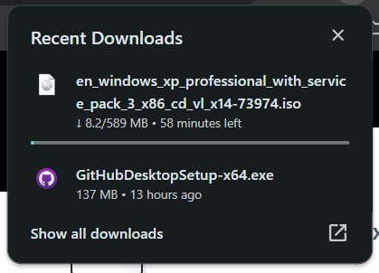

REFLECTION QUESTIONS

1. Why it is not advisable to use WindowsXP in real environment?

* Using Windows XP in a real environment is not a good idea because it's old, unsafe, and lacks support. Microsoft stopped updating it in 2014, so it's vulnerable to security threats. It also has compatibility issues with modern software and hardware, lacks features, and has no current web browser support. Using it can lead to legal problems in some cases. It's better to use a more recent and supported operating system for safety and performance.

1. When is the last date for Microsoft support WindowsXP?

* April 8, 2014

**Task 2**

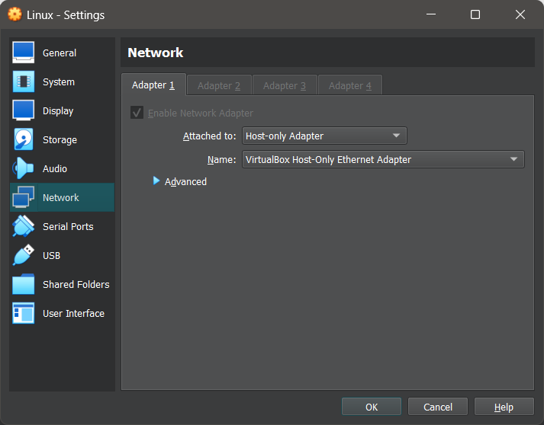

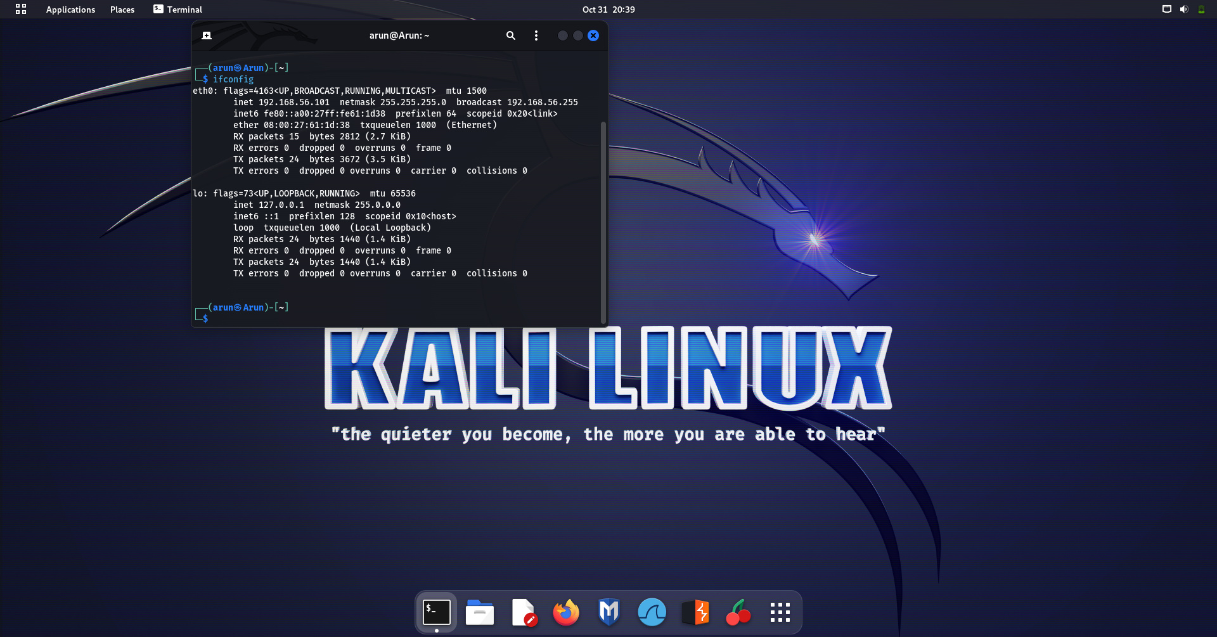



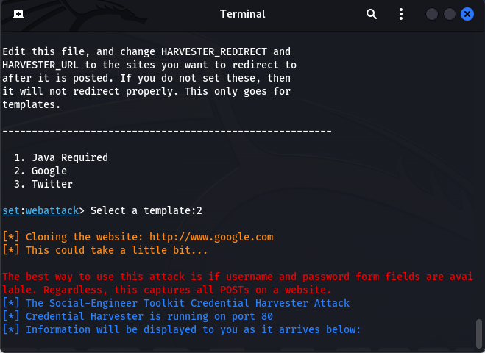

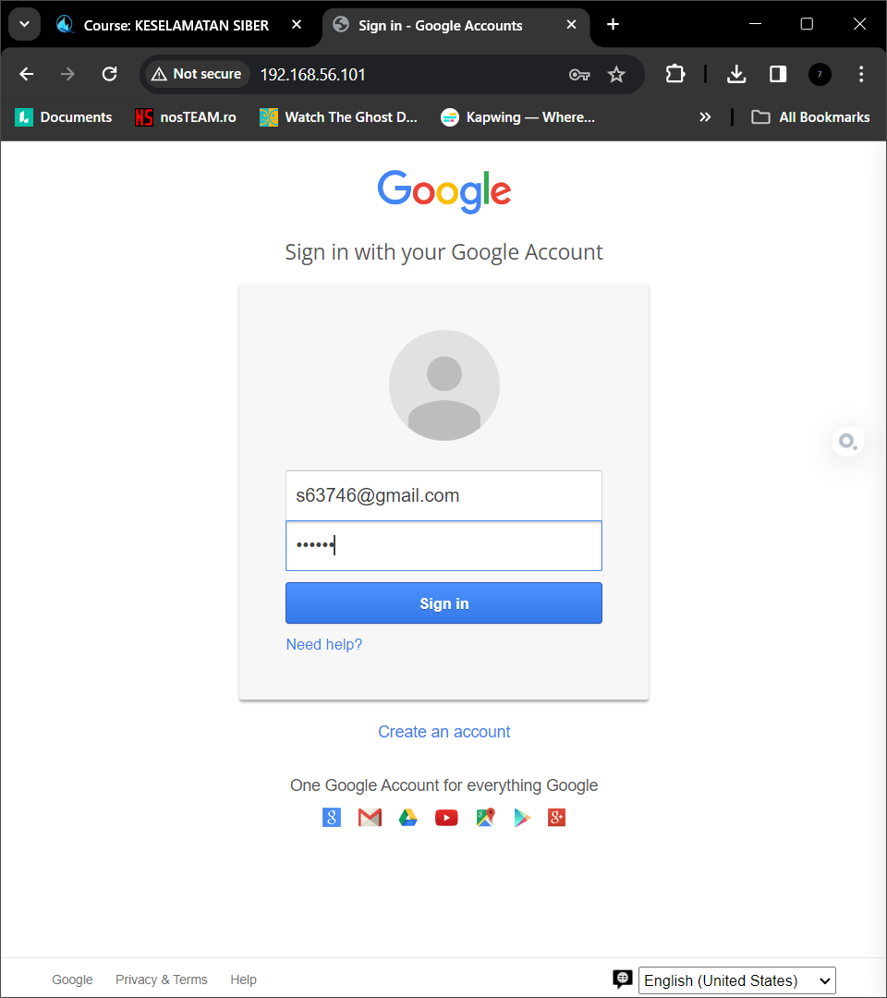

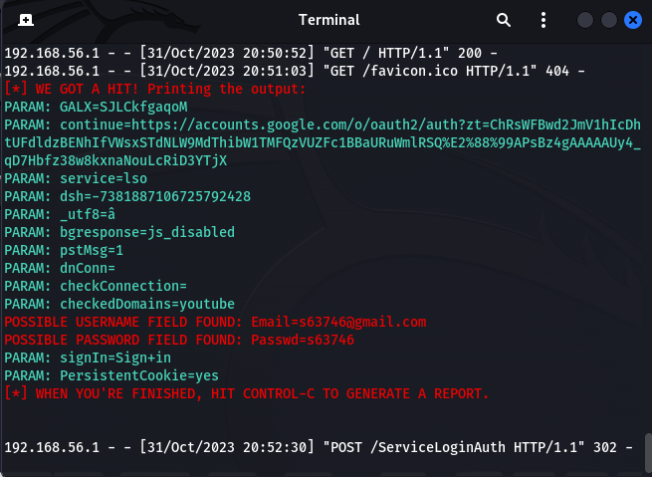

REFLECTION QUESTION

1. What are the steps to prevent people from falling into the trap of cloned websites?

* Learn about the danger.
* Check website URLs for any oddities.
* Don't click on unexpected links in emails or messages.
* Get apps and software from trusted sources.
* Keep your computer and software up to date.
* Use strong, unique passwords and consider a password manager.
* Enable multi-factor authentication when available.
* Be careful with personal information.
* Install antivirus and anti-malware software.
* Regularly review your accounts for suspicious activity.
* Report suspected cloned websites.

**Task 3**

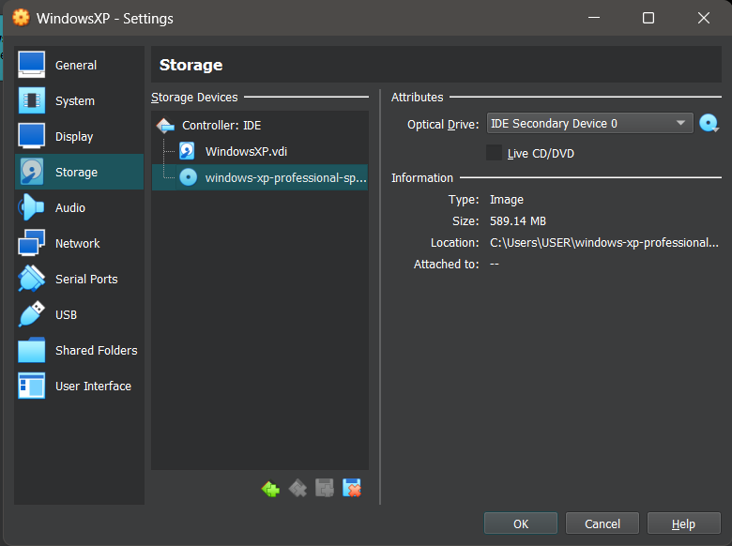

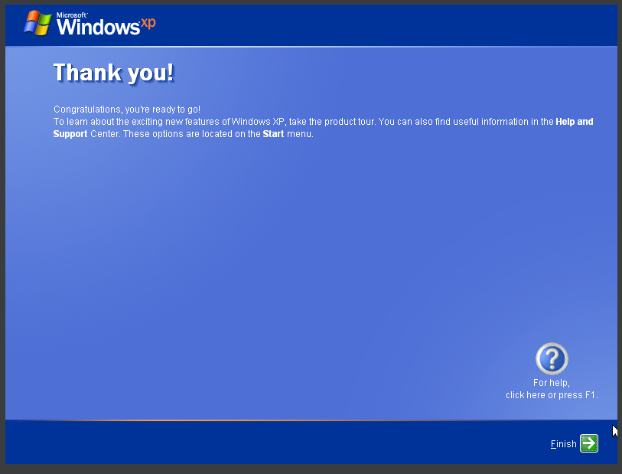

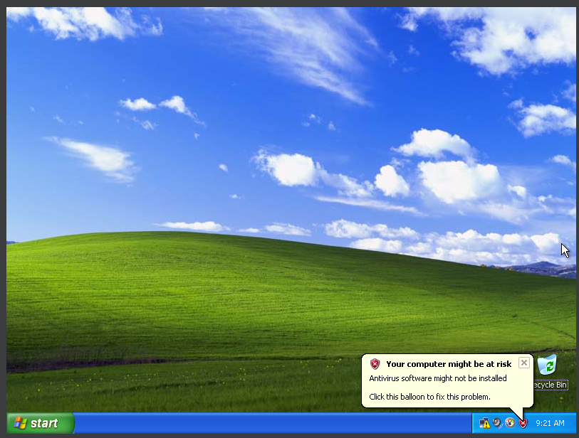

**Task 4**

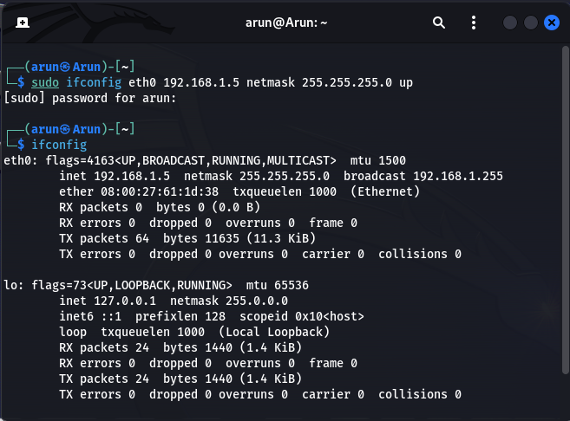

**Task 5**

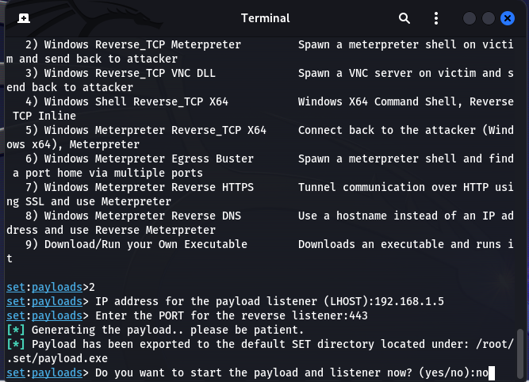

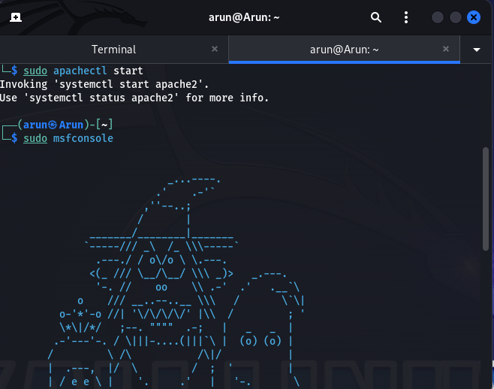

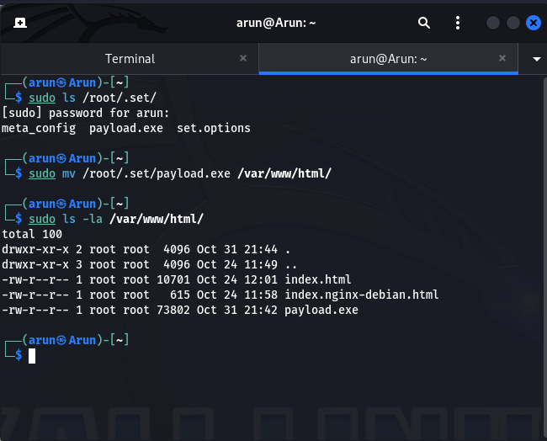

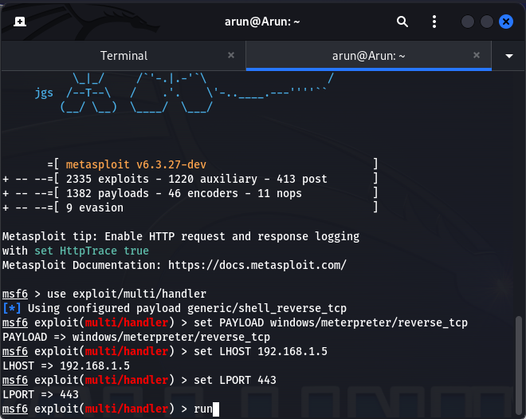

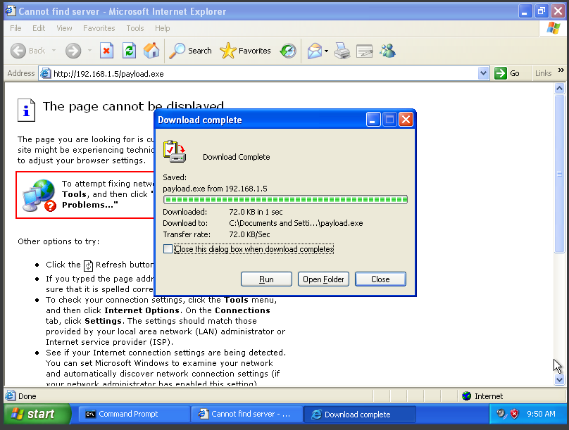

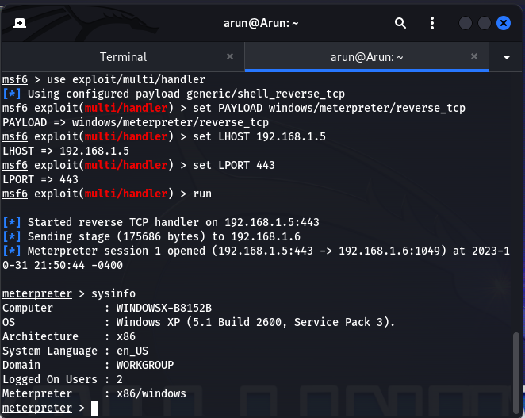

REFLECTION QUESTIONS

1. Based on your understanding, what is a social engineering attack?

* A social engineering attack is when bad actors manipulate or deceive people to get them to share sensitive information or do things they shouldn't.

1. Explain 5 ways for defending or mitigating against social engineering attacks.

* Train employees to be aware of these tricks.
* Use strong authentication methods.
* Control who has access to sensitive information.
* Set clear security rules and policies.
* Have a plan for dealing with social engineering incidents.

1. What are the common social engineering attacks that happen in our lives and how the attack can be prevented? Explain the attack and you may state more than one attack.

* Phishing: Be careful with emails or messages that look suspicious.
* Pretexting: Verify if requests for personal info are legitimate.
* Baiting: Don't download files from untrusted sources.
* Tailgating: Don't let unauthorized people into secure areas.
* Impersonation: Confirm the identity of anyone asking for unusual favors.

1. what trends do you see in social engineering attacks?

* Attacks are getting more sophisticated.
* Attackers use current events and technology for their schemes.
* They may focus on specific industries or organizations.

1. Is human behavior is one of the factors of social engineering attacks? Explain your answer.

* Yes, these attacks exploit human trust and biases to trick people into making mistakes.

1. How people can be safe from social engineering attacks?

* Teach people to recognize and respond to these tactics.
* Use strong security measures.
* Verify requests for sensitive info.
* Be cautious with unsolicited messages.
* Report suspicious activity.